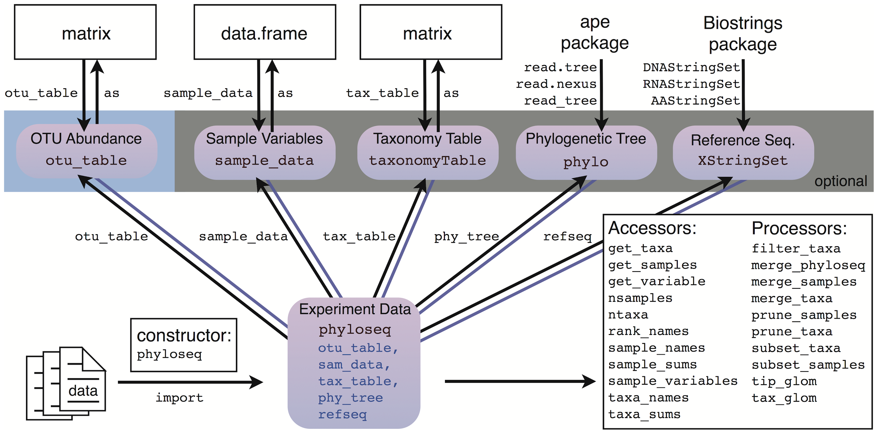

**If you can get the data into R, then you can get it “into” phyloseq.**

Constructors:

* otu_table - Works on any numeric matrix. You must also specify if the species are rows or columns
* sample_data - Works on any data.frame. The rownames must match the sample names in the otu_table if you plan to combine them as a phyloseq-object
* tax_table - Works on any character matrix. The rownames must match the OTU names (taxa_names) of the otu_table if you plan to combine it with a phyloseq-object.
* phyloseq - Takes as argument an otu_table and any unordered list of valid phyloseq components: sample_data, tax_table, phylo, or XStringSet. The tip labels of a phylo-object (tree) must match the OTU names of the otu_table, and similarly, the sequence names of an XStringSet object must match the OTU names of the otu_table.
* merge_phyloseq - Can take any number of phyloseq objects and/or phyloseq components, and attempts to combine them into one larger phyloseq object. This is most-useful for adding separately-imported components to an already-created phyloseq object.

**Note:** OTUs and samples are included in the combined object only if they are present in all components. For instance, extra “leaves” on the tree will be trimmed off when that tree is added to a phyloseq object.

More details at: <https://joey711.github.io/phyloseq/import-data.html>